LAB ASSIGNMENT-1.3

Task Description:#2

Use copilot to generate a is_prime() Python function.

Expected Output:

Function to check primarly with correct logic

Prompt 1: Write a python function is_prime() to check for a prime number.

CODE:

def is_prime(n):

    """Check if a number is a prime number."""

    if n <= 1:

        return False

    if n == 2:

        return True

    if n % 2 == 0:

        return False

    for i in range(3, int(n ** 0.5) + 1, 2):

        if n % i == 0:

            return False

    return True

# Example usage

print(is_prime(29))  # True, since 29 is a prime number

print(is_prime(15))  # False, since 15 is not a prime number

print(is_prime(2))   # True, since 2 is a prime number

print(is_prime(1))   # False, since 1 is not a prime number

OUTPUT:

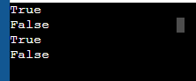

Task Description:#3

Write a comment like #Function to reverse a string and use Copilot to generate function

Expected Output:

Auto-completed reverse function

Prompt1:

Create a python function for reverse of a string

Code:

def reverse_string(s):

    return s[::-1]

# Example usage

print(reverse_string("hello"))  # "olleh", since the reverse of "hello" is "olleh"

print(reverse_string("Python"))

Output:



Task Description#4:

Generate both recursive and iterative versions of a factorial function using comments

Excepted Output:

Two working factorial implementations

Prompt 1:

Create a python recursive function for a factorial of number

Code:

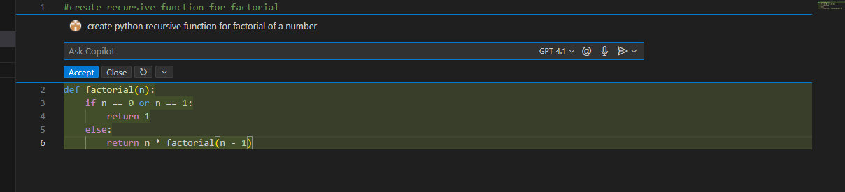

Prompt 2:

Create a python iterative function for a factorial of number

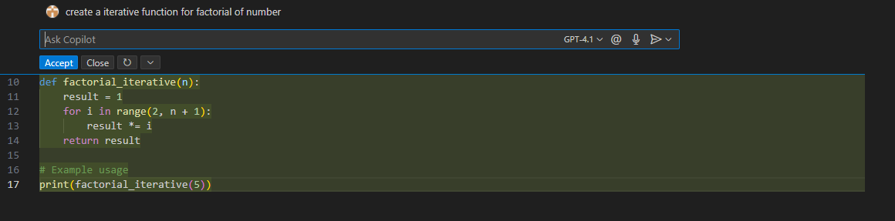

Output:

120

Task Description #5:

Use copilot to find the largest number in a list.Assess code quality and efficiency

Expected Output:

A valid function with your review

Prompt 1:

Create a python function to find the largest number in a list.

Code:

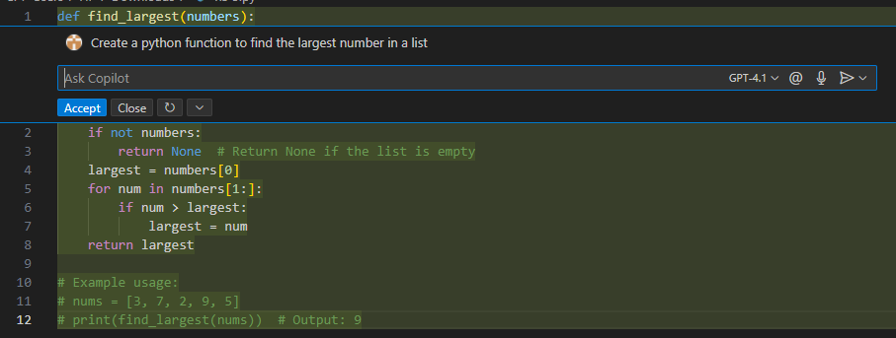

Output:

9